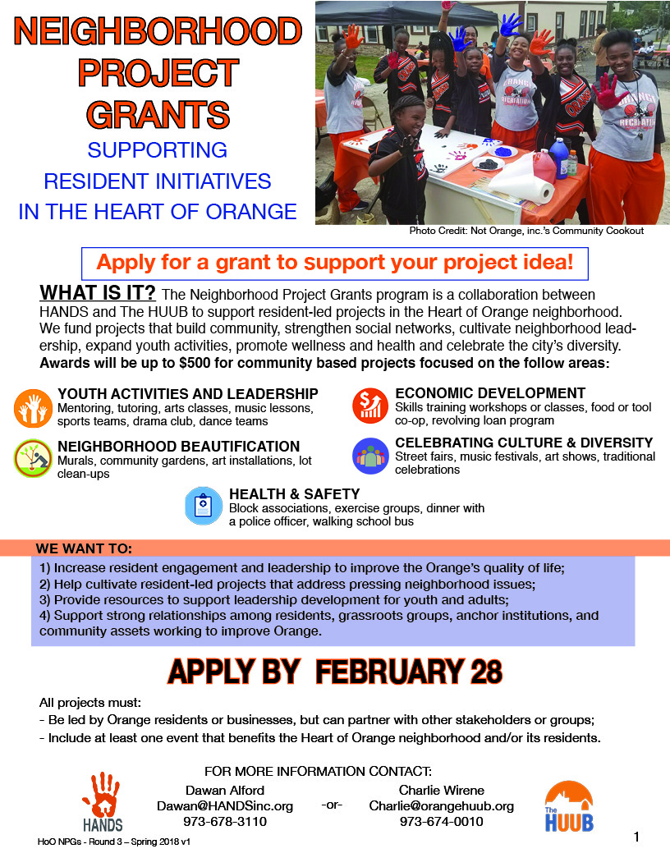
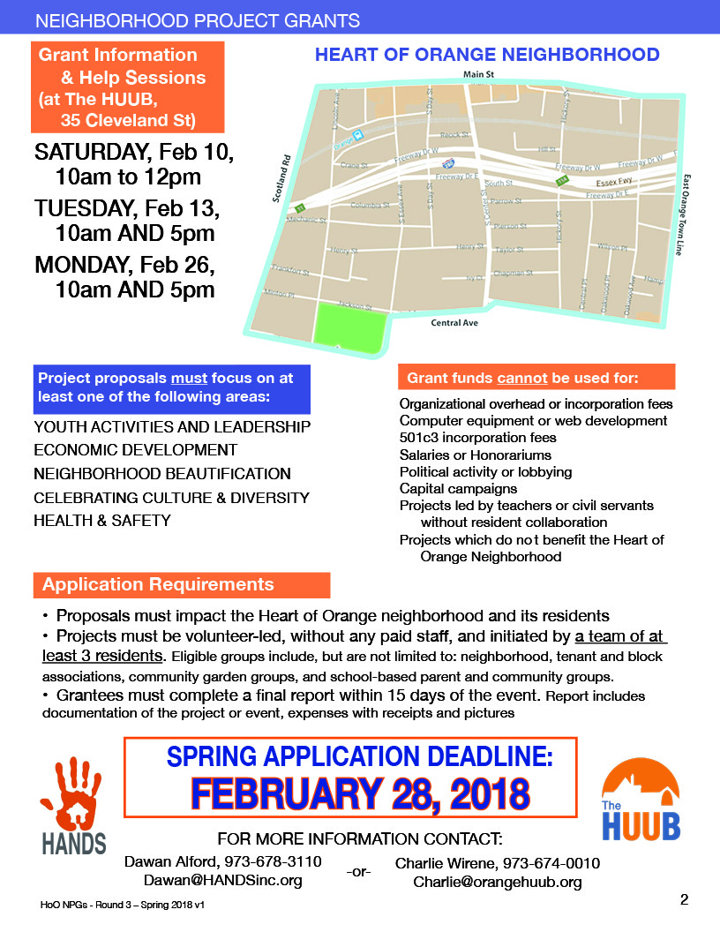
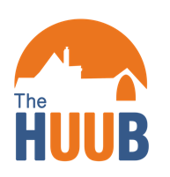
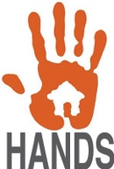
Neighborhood Project Grant Application

Project Title: _____________________________________________
Section 1: General Information
- What is your group’s name? _____________________________________________
- How many active members do you have? ___________________________________
- Please list at least three (3) contact names for your group, including primary phone numbers and emails. If there are more members of your group, please attach a list to the application.

- What is your group’s mailing address? ______________________________________

- When was your group formed? ____/________

- Is your group a registered 501©3 or New Jersey non-profit organization? ___ Yes ___ No

- Is this your group’s first project? ___ Yes ___ No

- Is your group on the web? How can we follow you? ____________________________________________________________________________

- Please briefly describe your group’s purpose (25 points):

Section 2: Project Description
- What is(are) your project’s primary community focus(foci)?
___ Youth Activities & Leadership ___ Cultural Diversity ___ Health & Safety
___ Economic Development ___ Neighborhood Beautification
- Project Description: Please describe your project in detail, including how it contributes to at least one of the project focus areas listed above. (75 points)
- Project Location:
  - Please state the address of the proposed project: _______________________________
  - Do members of your group live or work here? ___ Yes / ___ No

- Resident Outreach: How will you get neighbors actively involved? How many people do you expect to participate? (25 points)

- Community-wide Engagement: How will you work with local businesses, schools, and community-based organizations? (25 Points)

- Project Plan: Please include a detailed action plan that indicates all of the steps your group will take to do the project, following the format below. Add sheets if needed. (50 points)

Action | Person or people responsible for carrying out the action | Date(s) the action(s) will take place | Intended outcome(s)
Example: Distribute flyers to neighbors announcing the event and upcoming planning meeting | John Smith  Linda Jones | Jan 21-22  Feb 1-2  Feb 7-8 | Raise awareness about upcoming event; recruit new resident volunteers to attend planning meeting and take part in the event
- Materials On Hand: What materials or services does your group already have access to that will support your project? (30 points)

Item/resource | Description of use | Source/Vendor
Example: Tent | To serve as cover for volunteer check in and supply station. | Community Church

- Materials Needed: Please provide a budget including all planned project expenses, following the format below. Your budget items should not exceed $500. Grants do not cover personnel or ongoing costs. Budget should only consist of one-time expenses related to the project and/or items such as equipment or supplies. Grants will be awarded by direct purchase or by check if the applicant group is tax exempt. (30 Points)

Item | Description of use | (Optional) Source/Vendor | Cost
Example: Paint | To paint the walls surrounding the community garden. | Local Hardware Store | $50.00
 | Total:

- Moving forward: How will your group maintain or continue the changes your project is designed to achieve?(e.g., For a block cleanup, what is your group’s plan for keeping the block clean?) Please be specific. (50 points)

Section 3: Event Dates
On what date will you hold your event/s? _____________________________

What is the ‘rain date’ for your event/s? ______________________________

Please note that this is a firm date, so please discuss it with your group before making a decision.

Section 4: Prior Grantee Eligibility
Grantees from the first round of Neighborhood Project Grants (those awarded in June, July, and August 2017) are eligible to reapply this round if they have submitted all necessary documentation from their first project. Grantees from the second round of Neighborhood Project Grants (those awarded in November 2017) are ineligible to apply this round but will be eligible during the next round, which will open in May 2018.
Section 5: Grant Acknowledgement
By signing below, the grantee confirms that it is solely responsible for the content, activities, and consequences of the event, and that regardless of funding level awarded or method of payment, the grantee confirms that HANDS and The HUUB are not liable for any problem or damage related to the execution of the grant project. The grantee agrees to allow HANDS and The HUUB to use images or other media from their project for promotional purposes. The undersigned attests they are authorized to sign on behalf of the applicant/grantee group.
_____________________________ ___________________ __________
Signature Title Date
_____________________________ __________________________________
Print Name Group Name

Applications can be submitted:
In person: contact Charlie Wirene at 973-674-0010, or by email to arrange

By Email: Charlie@OrangeHUUB.org

By Fax: 973-678-0014

By Mail: Neighborhood Project Grants
ATTN: Charlie Wirene The HUUB
PO Box 998 Orange, NJ 07051

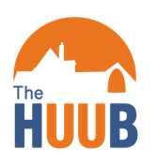
For more information or questions, please contact:

Charlie Wirene, The HUUB OR Dawan Alford, HANDS, Inc.
973-674-0010, ext 1 973-678-3110, ext 24
Charlie@OrangeHUUB.org Dawan@HANDSinc.org

